CLIENT TRUST REVIEW MARKETING TOOL
3-Year Checkup Reminder Postcard


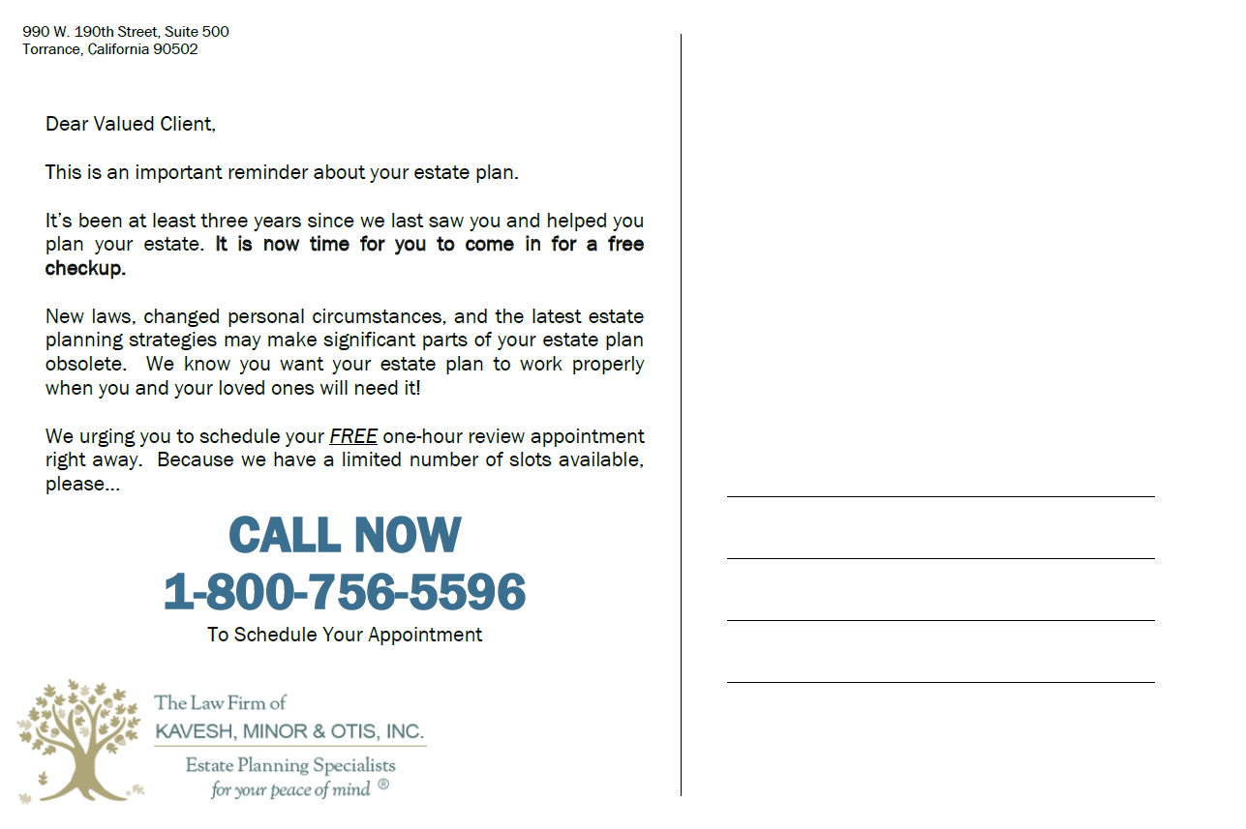
The law firm sends out postcards each month to clients who are due for their 3-year review (the following month). The template below allows for clients to write in their address themselves (similar to a doctor or dental office).

EXHIBIT 2

